# Raspberry Pi Servers

Written by Mark Webster, and ??

*Summary*: Learn to use a Raspberry Pi as a server.

## Introduction

Single board computers like the Raspberry Pi can be used as regular desktop computers for Internet browsing, word processing, games, or programming. However, due to their small size a Raspberry Pi in headless mode (no keyboard, no mouse, no monitor) can sit in a corner and function quite well as a dedicated server. This is in fact a common use for single board computers. Raspberry Pis are used as print servers, media servers, file servers, and web servers.

## Client-Server Model

Everyone who has used the Internet is familiar with the client-server model. The browser is the client and is located on the local device, the laptop, smartphone, or desktop computer. The browser communicates over a network to a remote computer called a server which is just a box in some big data center. This process of a local computer interacting with a remote computer which does all the heavy lifting, is used in many different ways.

Wikipedia covers the concept <https://en.wikipedia.org/wiki/Client%E2%80%93server_model>

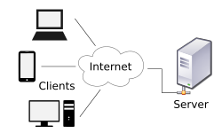

## VNC Server

Virtual Network Computing is basically a remote desktop. One local computer can view and interact with the graphical desktop environment of a remote computer. The mouse, keyboard, and monitor on the local computer functions as if they are physically connected to the remote computer.

To allow remote desktop sharing requires both a VNC server and and VNC viewer (client) software.

VNC Server Software

The RealVNC server software is free on the Raspberry Pi. For non-commercial use it can be downloaded from the RealVNC website: <https://www.realvnc.com/en/connect/download/vnc/>

The RealVNC software is pre-installed in Raspbian and is enabled from the preference menu “Raspberry Pi Configuration”

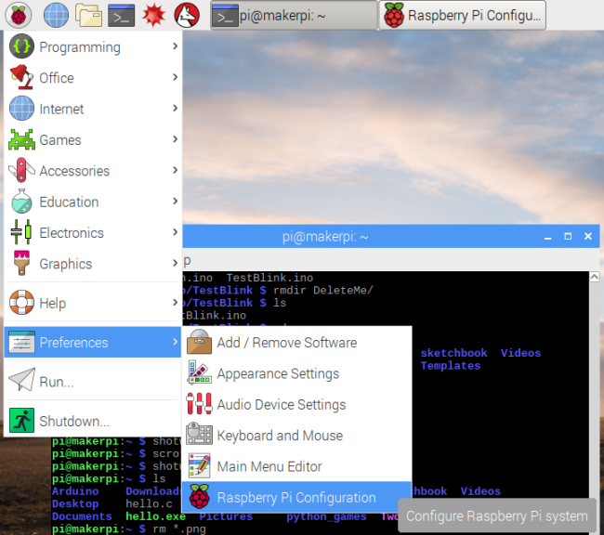

Click on the “Interfaces” tab and select the VNC enable radio button to turn on the VNC server.

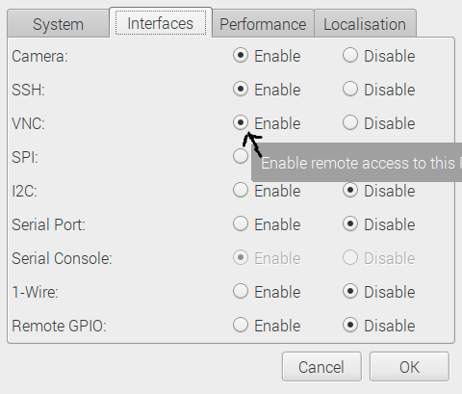

The Raspberry Pi configuration can also modified from the command line with:

“sudo raspi-config”. Scroll down with the arrow keys and select the “Interfaces” option using the Enter key or the <Select> button.

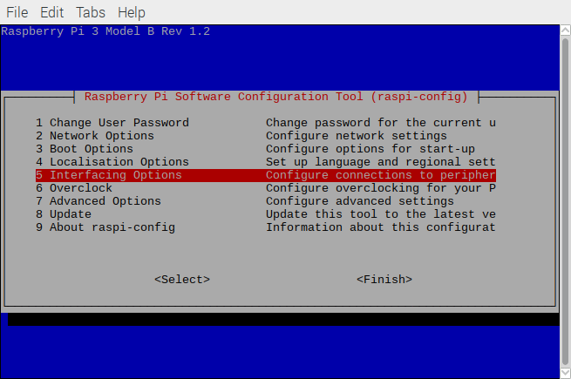

Within the Interfacing Options screen select VNC and toggle the option on. Enter or <Select> will bring up the screen to enable or disable the VNC server.

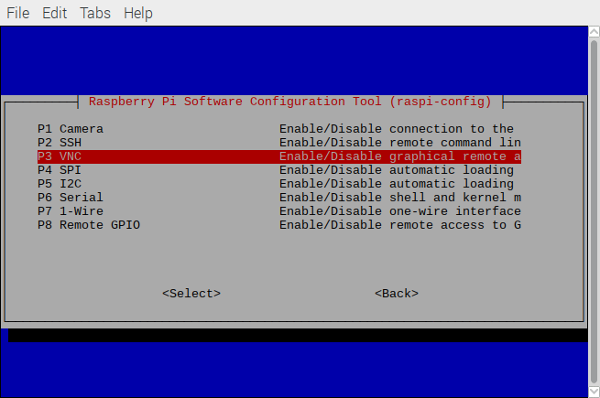

Enter or <Select> will bring up the screen to turn on or off the VNC server. Use keyboard tab to navigate between buttons.

Restart the Pi and the server will start. When the VNC server is running a VNC icon will appear in the top right of the toolbar.



VNC Client

The VNC client software is free and can be downloaded from the RealVNC website <https://www.realvnc.com/en/connect/download/viewer/>

It is called the VNC viewer, and is different software for each type of computer. It runs on all major operating systems and smartphones too.

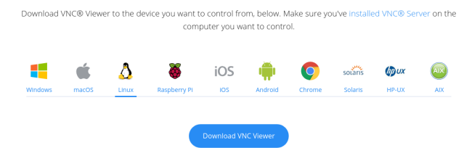

Once the VNC client is downloaded, when executed a window appears. Enter a new vnc client in the top text bar. Previously connected clients will appear as icons in the window. Double click on an icon to remotely connect to the other computer’s VNC server. This will allow the monitor, keyboard and mouse on the local computer running the VNC viewer to act as if they were attached to the remote computer.

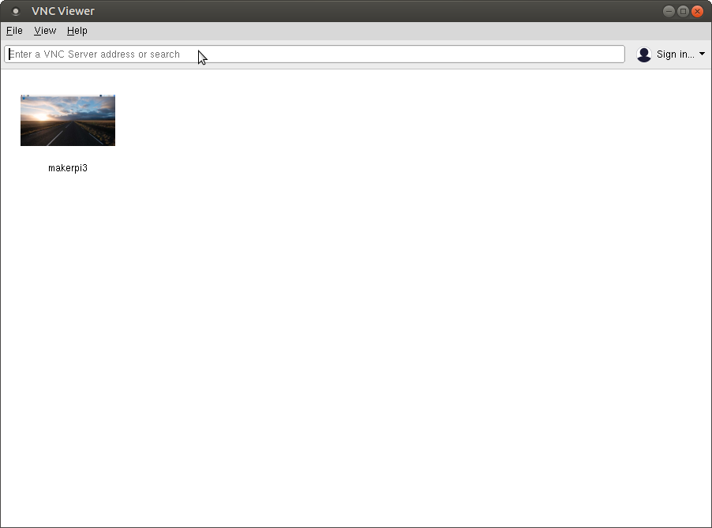

Here is another desktop Linux computer connected to a Raspberry Pi called “makerpi3”

After typing the IP address into the text box or double clicking on the pre-existing server icon, the viewer software will ask for the server’s password.

Notice how the VNC viewer window looks and works just like the screen connected to the remote Raspberry Pi.

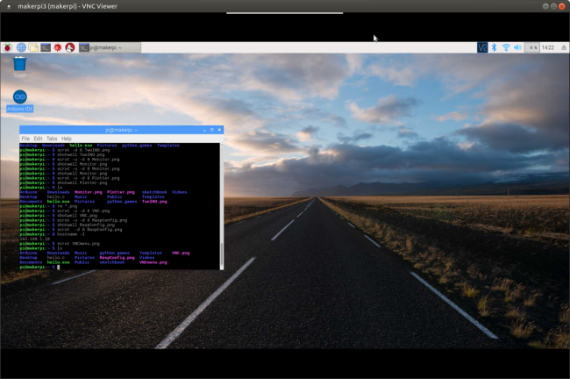

Logout when done with the remote computer. There is a hidden menu bar at the top of the window which appears when rolled over with the X or logout command.

#### Exercise 1: Connect with VNC

From a Raspberry Pi or laptop that is connected to the Makernet intranet, connect to another Raspberry pi. First find the IP address of the other Raspberry Pi and then launch the RealVNC viewer software.

## SSH Server

An SSH server allows a local computer to function like a terminal connected directly to a remote computer. SSH works in a command line environment.

The host computer must run the SSH server software, and the client computer must run some terminal emulation software with an SSH client.

Raspbian comes preinstalled with SSH server software. It can be enabled from the Raspberry Pi configuration menu on the Interfaces tab. Just click the radio button on SSH enable. See the section of enabling the VNC server for details.

To connect to an SSH enabled Raspberry Pi (or other computer) at the command line type:

“Ssh username@IP_address”

It will then ask for a password and if the first connection then it will validate the key.

Here is an example of the client “markw@markw-DX4300” connecting to the remote computer pi@makerpi. Once connected the keyboard and mouse on the local computer work as if they are connected to the remote computer. Typing “logout” leaves the session.

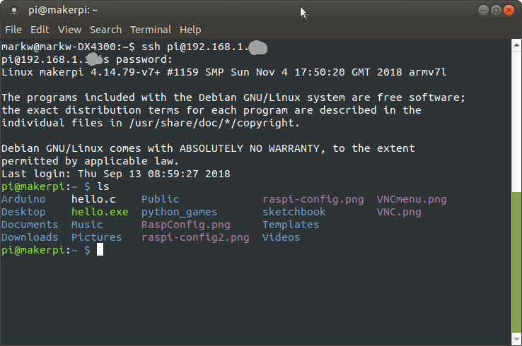

To copy files from the remote computer which has SSH enabled, use the scp command.

“scp username@IP_address:file_to_copy local_file_name”

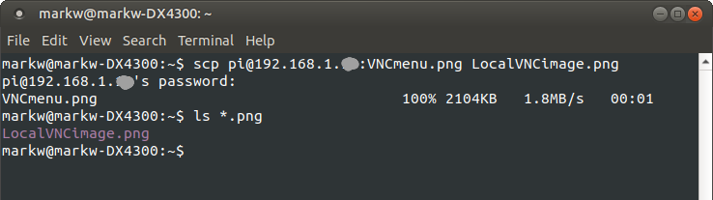

#### 

#### Exercise 2: SSH

From a Raspberry Pi or a laptop on the Makernet intranet, SSH to another Raspberry Pi computer. If the other computer has a monitor and keyboard, find the remote computer’s IP address by the command line “hostname -I” command. Create a file with “touch newfile.txt” just to show the SSH connection is a real terminal window onto the other machine.

## Print Server

Some printers are network ready and can be shared over a local intranet or even the Internet. However, older or less expensive printers lack that capability. An inexpensive remedy is to attach a single board computer like a Raspberry Pi to the non-networked printer and run a print server on the Pi. Miraculously the printer can now be shared with many other computers or even smartphones.

The same concept can be applied to sharing 3D printers, scanners, or other physical peripherals.

CUPS

The most common print server software in the Linux world is called CUPS. (Common Unix Printing System).

On the local computer the command line to install (after an update and upgrade) is:

“sudo apt-get install cups”

Next the local user must be added to the group that has permission to print.

“sudo usermod -a -G lpadmin pi”.

To allow other computers to print use the cups control command, then restart the cups server.

Another approach is:

**$ sudo cupsctl --remote-any**

**$ sudo /etc/init.d/cups restart**

To add printers or manage the server open a browser on the Makernet local network and in the browser command box type in the IP address of the Raspberry Pi and the port of :631. For example, type <https://10.0.0.11:631/> where the 10.0.0.1 is replaced with the server IP address.

The CUPS server has a web page for control.

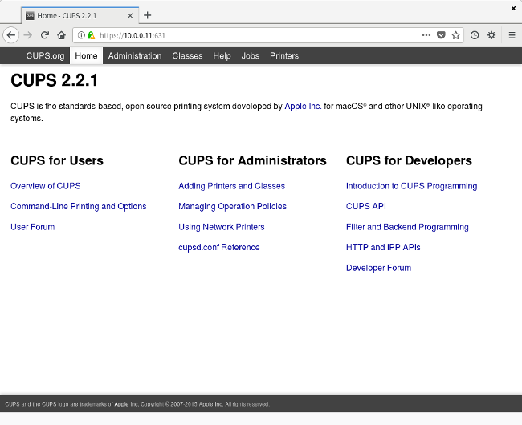

Add printers to CUPS with

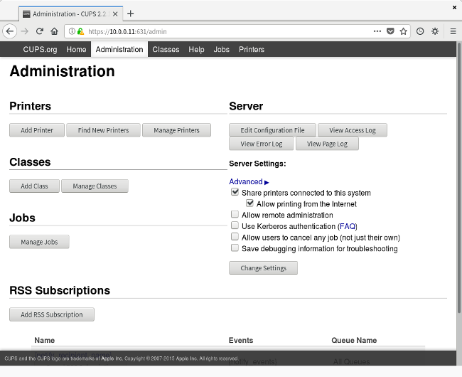

Be sure to check the Share printers checkbox.

USB printers can be searched for and added easily.

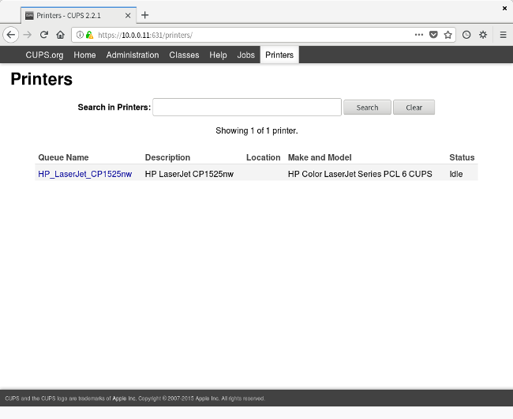

On the client computer, for Linux systems just go to the System menu and add a printer. Select network printers.

For Windows and MacOS computers see the operating system reference (or search the Internet) for sharing networked printers. Using a Linux printer from Windows is tricky and won’t be covered here.

## File Server

Smart houses often have NAS drives (Network Access Drives) to share large files like movies. NAS drives are convenient but expensive.

With a low cost USB external drive and a Raspberry Pi one can make an inexpensive NAS server.

To share files requires a larger external USB hard drive and file server software.

If the Raspberry Pi will only be used as a NAS, there is a dedicated operating system called

<https://www.openmediavault.org/>

If the Raspberry Pi will have other functions, install the open source SAMBA server software if files must be shared with non-Linux computers.

SAMBA

To share files and directories between the Raspberry Pi and Windows computers, the SAMBA software is used. To share between two Raspberry Pi computers the NFS software can be used.

Install the samba server software from the command line with:

sudo apt install samba samba-common-bin

Edit the samba configuration file with:

sudo nano /etc/samba/smb.conf

Restart the samba server with:

sudo nano /etc/samba/smb.conf

When the files to share are on the SD card and not a USB drive then configure the directories:

sudo mkdir /home/shares

sudo mkdir /home/shares/public

sudo chown -R root:users /home/shares/public

sudo chmod -R ug=rwx, o=rx /home/shares/public

At the bottom of the samba configuration file add the lines:

[public]

comment = public storage

path = /home/shares/public

valid users = @users

force group = users

create mask = 0660

directory mask = 0771

read only = no

Create a samba password. Then add a user “pi” to the samba server with

sudo smbpasswd -a pi

If the files are on an external USB drive, the drive must be formatted with Linux ext3 or ext4, not the MSDOS Win32.

Find the device the USB drive is connected to with dmesg then unmount the drive, and then create and link a director to the external drive:

umount /dev/sda1

sudo mkfs.ext4 /dev/sda1

sudo mkdir /home/shares/public/disk1

sudo chown -R root:users /home/shares/public/disk1

sudo chmod -R ug=rwx,o=rx /home/shares/public/dis

Mount the external USB drive again.

sudo mount /dev/sda1 /home/shares/public/disk1

Then edit the fstab file so the drive automatically is mounted on Raspbian startup.

sudo nano /etc/fstab

/dev/sda1 /home/shares/public/disk1 auto noatime,nofail 0 0

On windows connect to the network drive.

There are other file sharing services like NFS

<https://help.ubuntu.com/community/SettingUpNFSHowTo>

## Web Server

Hard to imagine a world without browsers and Internet servers. Many people and organizations have their own web sites hosted on a remote server somewhere. While convenient, these hosting services charge a monthly or annual fee. A low cost alternative is to set up a web server on a Raspberry Pi and host the website on that inexpensive machine.

Most larger web hosting services run the open source software called Apache on Linux systems. A few Microsoft Windows servers run IIS. The Apache software runs on a Raspberry Pi however, Apache runs better on faster computers with more memory. For single board computers with limited memory and CPU speed, the preferred alternative is the open source NGINX server software. It runs about 2.5 faster for static HTML applications.

#### NGINX

The nginx software is pronounced “Engine X”. First install the software from the command line:

sudo apt-get install nginx

Start the web server running with:

sudo /etc/init.d/nginx start

To test the nginx web server, on the server pi open a browser and type “<http://localhost/>”

From another computer on the same network open a browser and type the IP address of the Raspberry pi computer in the address box. The browser should display:

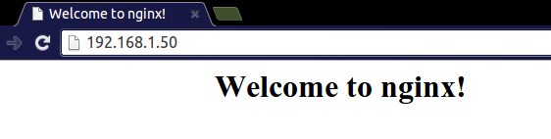

To change the default web page NGINX defaults its web page location to /var/www/html on Raspbian. Navigate to this folder and edit or replace index.nginx-debian.html as you like. You can confirm the default page location at /etc/nginx/sites-available on the line which starts with 'root', should you need to.

PHP service can also be easily added to the nginx server. See the official documentation at:

<https://www.raspberrypi.org/documentation/remote-access/web-server/nginx.md>

#### Exercise 3: Connect to web server

On a laptop or another Raspberry Pi that is on the same network (Makernet) as the server Pi, open a browser. After finding the IP address of the server connect to the default web page. For example,

<http://192.168.0.1/>

To open a specific file put it after the IP address <http://192.168.0.1/maker.php>

Edit the HTML of the default NGINX web page and test from the remote laptop or Pi.

Connect via VNC or SSH. Then change to the default directory /var/www/html

With nano edit the file “maker.php” to add your name

<p> your name was here </p>

Save the edited file and reload the page in the browser.

If the NGINX server has had PHP installed default web page can include a simple PHP command like “<?php echo phpinfo(); ?>”

#### Example 4: WGET a file

From the command line download a file from the web server using the wget command. For example,

Wget <http://192.168.0.112/maker.php>

Then cat the file to see what is in the file. Most browsers also have a way to view the source in a page.